Practical
SUMMARY:-
In this practical, I studied Max Heap Sort and learned how a Max Heap is created and used to arrange numbers from smallest to largest.

Max Heap Sort is a comparison-based sorting algorithm that uses a Max Heap data structure. In a Max Heap, the parent node is always greater than or equal to its children. The largest element is repeatedly moved to the end of the array until all elements are sorted in ascending order.

Output
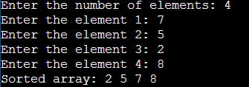

Time Complexity:
Best Case O(n log n)
Average Case O(n log n)
Worst Case O(n log n)

Conclusion-Thus, Max Heap Sort successfully sorts the given elements in ascending order by repeatedly building and maintaining a Max Heap. It has a time complexity of O(n log n) and does not require extra memory for another array.

